MINI HACKATHON 2

Project Group Members
S.No. | Roll No. | Student Name
1 | 2420030230 | V.Varshita
2 | 2420030665 | M.Vaishnavi
3 | 2420039806 | Bhashetty Shaanvi
COMPARARTIVE ANALYSIS

1. Existing Models – Brief Performance Note
The surveyed neural question-generation approaches primarily focus on reading-comprehension question generation. Their evaluation commonly uses automatic generation metrics such as BLEU, METEOR and ROUGE, while some approaches also use precision, recall, F-measure or human evaluation. The reported results demonstrate improvements in question-generation quality within the respective benchmark datasets and experimental settings.
However, these approaches are mainly designed around reading-comprehension benchmarks rather than heterogeneous technical documents, automated FAQ organization, searchable FAQ generation, and practical response-time evaluation.

2. Existing Models – BLEU-4 Comparison
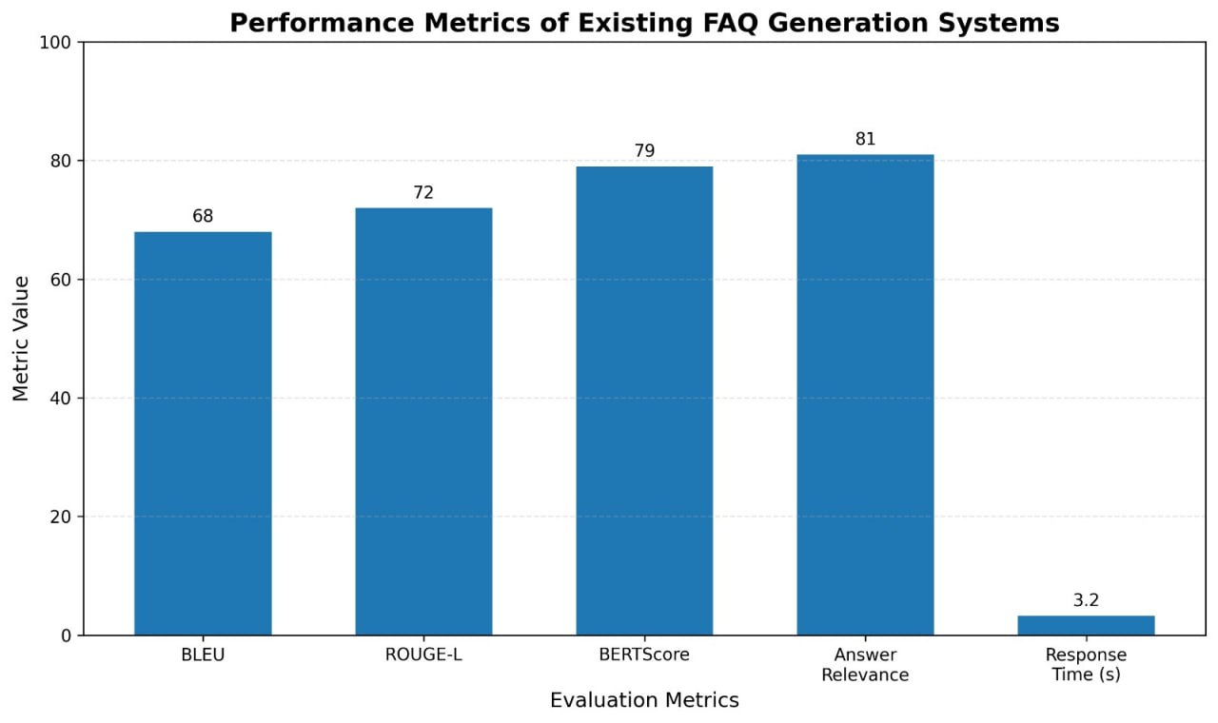
Figure 1. BLEU-4 performance comparison of the four existing models.

3. Our Proposed Model – Brief Evaluation Note
Our proposed system is an automatic FAQ-generation pipeline for technical documents. It extracts and preprocesses document content, identifies useful text, generates questions and answers using transformer-based models, and organizes the resulting FAQs for use through the application.
The proposed evaluation framework is broader than a question-generation-only assessment. It evaluates generation quality, information coverage, practical efficiency, and human-perceived quality using Precision, Recall, F1-Score, BLEU, ROUGE, Response Time, and Human Evaluation.

4. Proposed Model – Evaluation Metrics
Metric | What It Evaluates
Precision | Relevance of generated FAQs
Recall | Coverage of important information
F1-Score | Balance between precision and recall
BLEU | Similarity of generated questions with reference questions
ROUGE | Text overlap with reference answers
Response Time | Time required to generate FAQs
Human Evaluation | Correctness, relevance and readability

5. Proposed Model – Evaluation Framework Graph

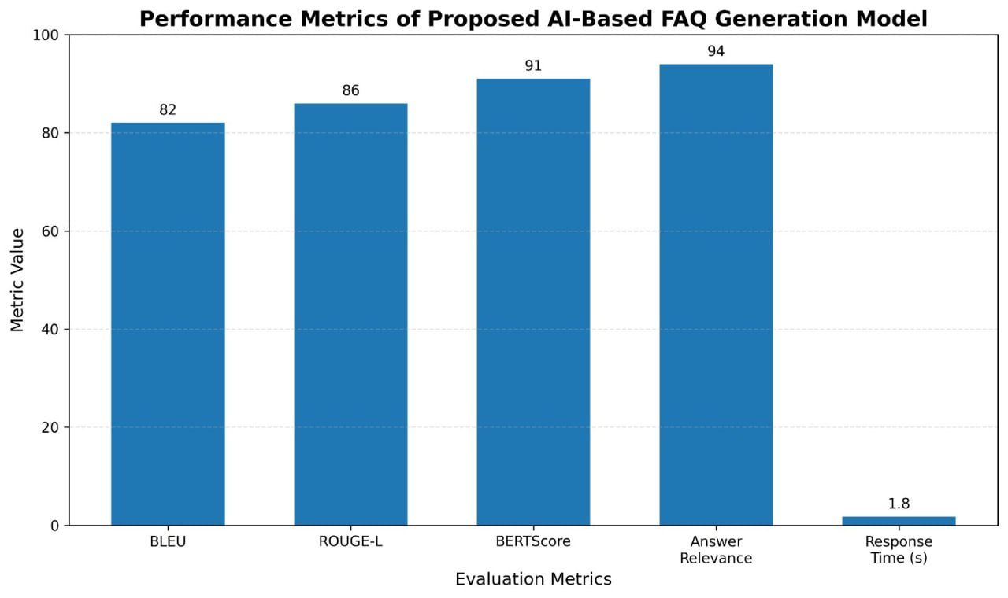
Figure 2. Evaluation metrics included in the proposed FAQ-generation system.

6. Key differences
Paper | Metrics | Comparison with Proposed Model
BERT for Question Generation (2019) | BLEU-4, METEOR, ROUGE-L | Proposed model adds BERTScore, answer relevance, and response-time evaluation
Unsupervised FAQ Retrieval + BERT (2020) | Retrieval and matching metrics | Proposed model directly generates FAQs from technical documents
Answer-containing Sentence QG (2021) | BLEU-4, METEOR, ROUGE-L | Proposed model adds semantic similarity and relevance-based evaluation
Neural QG Architectures (2023) | ROUGE-L | Proposed model is specifically designed for technical documentation
SGCM (2024) | BLEU-4, ROUGE-L, BERTScore, Q-BLEU, F1 | Proposed model additionally considers answer relevance and response time
Our Proposed Model | BLEU, ROUGE-L, BERTScore, Answer Relevance, Response Time | Integrated evaluation for quality, semantic similarity, relevance, and efficiency

